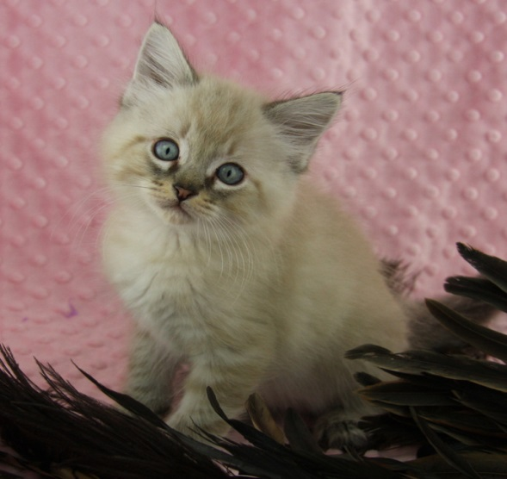

(360) 457-8206

www.ophumanesociety.org



Contact us today to learn how YOU can foster kittens!

• FREE training and mentors

• Foster supplies provided

• Learning experience for the whole family

• Save lives and promote pet adoption!

Love Kittens? We Do!