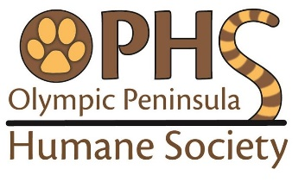
OLYMPIC PENINSULA HUMANE SOCIETY
1743 Old Olympic Hwy, Port Angeles, WA 98362 – (360)457-8206

<< DOG DONATION WISH LIST >>
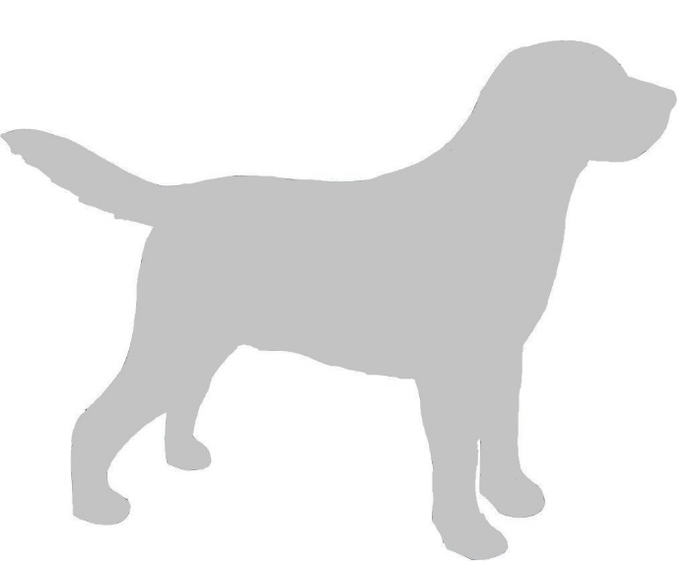
Daily Use Items:
- Dry dog food – any brand of ADULT (not puppy!) maintenance food will be accepted, but we prefer Purina, Pedigree, Costco/Kirkland brand (and similar or higher-quality brands) – both large and small breed varieties. (We do not feed our dogs any brands such as: Ol’ Roy, Gravy Train, or Alpo)
The dogs eat at least 50 lbs of dog food each day!
- Bleach and Liquid Laundry Detergent
We run 4 to 6 laundry loads of dog bedding and towels each day!
- Small-sized treats for training
We work with the dogs and give treats every day!
- Paper Towels
We use up a roll of paper towels each day!
Extras
- Chew treats/chew bones/pig rolls to reduce boredom
- Pill Pockets to give medications
- Canned dog food for senior dogs
- Small-sized dog beds that can be laundered several times

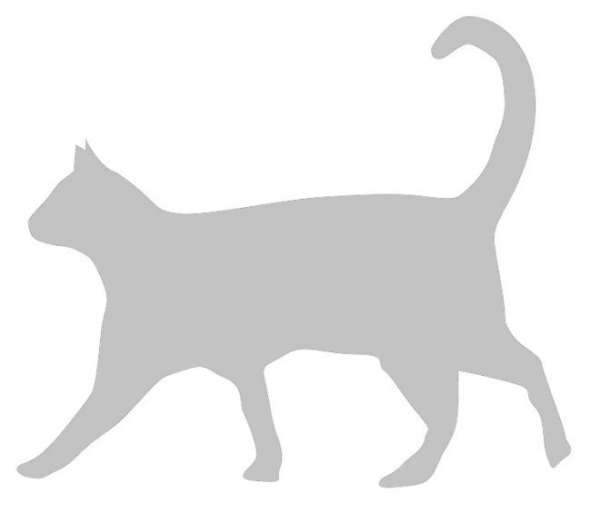
<< CAT DONATION WISH LIST >>
Daily Use Items:
- Kitty litter (non-clumping AND clumping)
The cats go through about 50 lbs of kitty litter every day!
- Dry cat (and kitten!) food
The cats and kittens eat about 20 lbs of food every day!
- Bleach and Liquid Laundry Detergent
We run at least 4 loads of kitty laundry every day!
- Paper Towels
We use up a roll of paper towels each day!
Extras
- Medium sized exam gloves for cleaning
- Cat nip for reducing anxiety and inducing relaxation
- Non-seafood flavored canned food for kittens
- Specialty treats – grain free or high-quality treats for socializing
- Cat beds that can be laundered several times
- Cardboard scratchers for fun and exercise

Other accepted donations: blankets and towels, kennels/crates/carriers, ex-pens, collars and leashes, rabbit/guinea pig/hamster/rat/other small animal items, and any other animal-related items in good useable condition.

Donations we CANNOT accept: Mattresses, bed pillows, old clothing or rags, ripped blankets, foam pads, broken crates/kennels, old appliances, prescription medications.
Note: Currently we have a large supply of pee pads and rawhide and do not need these items, thank you.

